**MINISTRY OF EDUCATION AND TRAINING**

**FPT UNIVERSITY**

Capstone Project Document

The Traffic Sign Recognition and Training

|  |  |
| --- | --- |
| **Group 2** | |
| **Group member** | Mai Văn Tân – Team Leader – SE90061  Bùi Việt Phong – Team Member - SE60747  Hồ Đắc Nghĩa – Team Member - SE60628  Trần Lê Tuấn – Team Member - 60350 |
| **Supervisor** | Mr. Kiều Trọng Khánh |
| **Ext. Supervisor** | N/A |
| **Capstone Project code** | TSRT |

-Ho Chi Minh City, 01/2014-

*This page is intentionally left blank*

***ACKNOWLEDGEMENTS***

# Table of Contents

Table of Contents 4

List of Tables 5

List of Figures 6

Definitions, Acronyms, and Abbreviations 6

Report No.2 Software Project Management Plan 7

1. Problem Definition 7

1.1 Name of this Capstone Project 7

1.2 Problem Abstract 7

1.3 Project Overview 7

2. Project organization 9

2.1 Software Process Model 9

2.2 Roles and responsibilities 9

2.3 Tools and Techniques 10

3. Project Management Plan 11

3.1 Iteration 11

3.2 Iteration Detail 12

3.3 All Meeting Minutes 14

4. Coding Convention 15

# List of Tables

Table 1: Hardware Requirement for Server 8

Table 2: Hardware Requirement for Web User 8

Table 3: Hardware Requirement for Mobile User 9

Table 4: Roles and Responsibility Details 10

Table 5: Iteration 12

Table 6: Phase 1: Preliminary Investigation or Analysis 12

Table 7: Phase 2: Traffic Sign Detect & Recognize 13

Table 8: Phase 3: Student Management 13

Table 9: Phase 4: Traffic sign mange 13

Table 10: Phase 5: Search traffic sign 14

Table 11: Phase 6: History and report manage 14

# List of Figures

Figure 1: Agile Development Model 9

# Definitions, Acronyms, and Abbreviations

# Report No.2 Software Project Management Plan

## Problem Definition

### Name of this Capstone Project

The Traffic Sign Recognition and Training (TSRT)

### Problem Abstract

Now a day, the traffic system is expand more than before. Beside that the traffic sign use to control traffic is developed to help people when join in the traffic. In Vietnam, we have more than 200 traffic signs, this may cause the difficult to people when meet a new traffic sign. On the other hand, internet and smartphone is more popular in Vietnam. Now it’s easy to have a smartphone with internet connection. That is the reason we want to build a system to help people find information about any traffic sign easily. So people can know more about the sign and traffic rule in each traffic sign, help them join in traffic easier and safer.

### Project Overview

#### The Current System

Below are some current system:

* Search using book:

+ Advantages: clearly, accurate information.

+ Disadvantages: slow and not update regularly.

* Current application:

+ Advantage: update regularly, easy to use.

+ Disadvantages: few information (just have basic information about traffic sign), search slow.

* Using internet:

+ Advantages: provide updated information.

+ Disadvantages: search slowly, need internet connection, too many useless information.

#### The Proposed System

* Develop a recognition system that support auto detect and recognize traffic sign using smartphone’s camera.
* Support more information about the traffic sign: penalty fee, view history.
* Support user learn traffic sign.

##### Web

* The admin can manage information about system, staff and users.
* The system provides a method for admin to set permission for staff, select the user in the database to set permission.
* The system provides a method for admin configure system.
* The admin can make statistic about user account (user and staff).
* Staff cans manager traffic sign, add/edit/delete traffic sign.
* Staff cans manager report, make statistic about traffic sign report.
* The system will make a traffic sign take note for user. Support sticker used to learn for user.
* The system will provide a method for user upload image to website. Then, the system will recognize the image and give information for user.
* The system will provide a method for user view user’s history, user can send report if have any error happen.

##### Mobile

* The mobile version also allow guest to register a new account.
* The user or guest can take a photo of traffic sign to make auto search about its information.
* In case the result is wrong, user or guest can send a report about this result.
* Allow user to add search result into favorite list for learning purpose.

#### Boundaries of the System

* The system is intended for almost Vietnam’s land traffic sign.
* Using in normal weather condition (sunny, cloudy...) and traffic sign must be in good state (In original shape, isn’t covered by other objects...)
* The system is intended for learning purpose only.
* The language of the system is Vietnamese
* The complete product includes:

+ The website, for admin, staff, user and guest to interactive with the system.

* + Mobile Application for user and guest.
* + All the process involved document.

#### Development Environment

##### Hardware requirements

**For server**

|  |  |  |
| --- | --- | --- |
| Windows | Minimum Requirements | Recommended |
| Internet Connection | 4Mbps | 8 Mbps |
| Operating System | Ubuntu 12 | Ubuntu 13.x |
| Computer Processor | Intel® Core 2 Duo | Intel® Core(TM) i5 CPU , M 460 @ 2.53GHz |
| Computer Memory | 1GB RAM | 3GB or more |

Table 1: Hardware Requirement for Server

**For Web User**

|  |  |  |
| --- | --- | --- |
| Web | Minimum Requirements | Recommended |
| Internet Connection | 2Mbps | 4Mbps |
| Web Browser | Chrome 20 | Chrome 31 |

Table 2: Hardware Requirement for Web User

**For Mobile User**

|  |  |  |
| --- | --- | --- |
| Mobile | Minimum Requirements | Recommended |
| Internet Connection | 2Mbps | 4Mbps |
| Operating System | Android 4.0 or later version | Android 4.4 |
| Hardware | Touchscreen, Camera 3.0 MP or above | Touchscreen, Camera 5.0 MP or above |
| Memory | 512 MB or more | 1 GB or more |

Table 3: Hardware Requirement for Mobile User

##### Software requirements

* Microsoft Windows 7 Service Pack 1, Ubuntu 13: operating system and platform for development.
* MySql 5.5.20
* StarUML 5.0: used to create models and diagrams
* Skype: used for communication and meeting
* Visual Studio 2012: used to implement recognition module.
* Eclipse Juno 4.4, Android SDK 22.0.5, ADT 22.0.5 & JDK 7u25: used to implement mobile application.
* Google Code & TortoiseSVN: used for source control.

## Project organization

### Software Process Model

Project is developed under agile model.

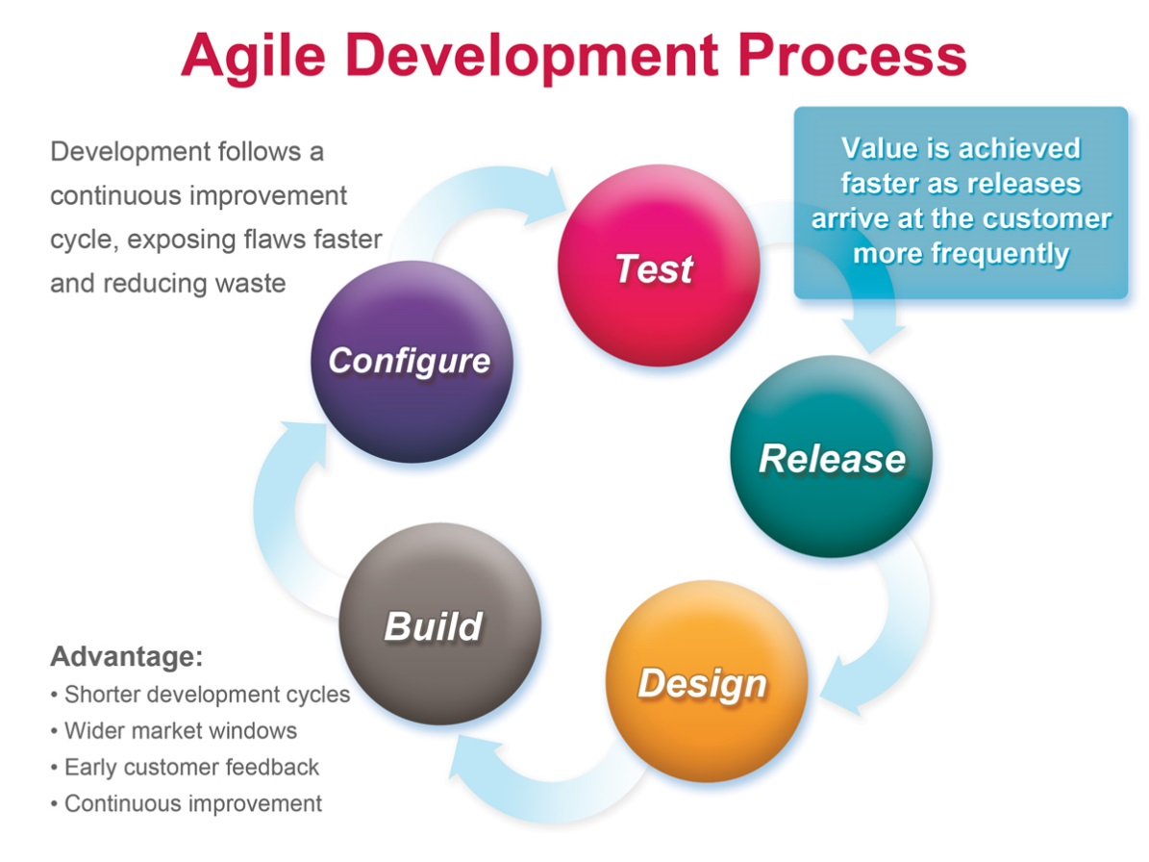

Figure 1: Agile Development Model

[<http://masokotanzania.com/5-steps-to-making-agile-development-work>]

### Roles and responsibilities

|  |  |  |  |
| --- | --- | --- | --- |
| **No** | **Full name** | **Role in Group** | **Responsibilities** |
| **1** | Kiều Trọng Khánh | Project manager | * Specify user requirement * Control the development process * Give out technique and business analysis support |
| **2** | Mai Văn Tân | Team Leader, BA, DEV, Tester | * Managing process * Designing database * Clarifying requirements * Prepare documents * GUI Design * Create test plan * Coding * Testing |
| **3** | Bùi Việt Phong | Team Member, BA, DEV, Tester | * Designing database * Clarifying requirements * Prepare documents * GUI Design * Create test plan * Coding * Testing |
| **4** | Hồ Đắc Nghĩa | Team Member, BA, DEV, Tester | * Designing database * Clarifying requirements * Prepare documents * GUI Design * Create test plan * Coding * Testing |
| **5** | Trần Lê Tuấn | Team Member, BA, DEV, Tester | * Designing database * Clarifying requirements * Prepare documents * GUI Design * Create test plan * Coding * Testing |

Table 4: Roles and Responsibility Details

### Tools and Techniques

- Front-end technologies: HTML5, CSS3, JavaScript, jQuery, AJAX.

- Back-end: Website: MVC3

- Web Service: Axis2

- Mobile App: Android - Java.

- Web Server: Tomcat 7.0.

- Database Management System: MySql 5.5.20

## Project Management Plan

### Iteration

|  |  |  |  |  |  |
| --- | --- | --- | --- | --- | --- |
| **Phase**  **/Iteration** | **Description** | **Deliverables** | **Resource needed** | **Dependencies and Constrains** | **Risks** |
| **Preliminary Investigation or Analysis** | - Study similar existing systems.  -Identify and clarify requirements for the system in general. | -Introduction of proposed system.  -Main functions.  -Project Iteration Plan. | 30 man-days | N/A | Project may  not be feasible  for developing  because lack of technologies  and/or data |
| **Traffic Sign Detect & Recognize** | - Study traffic sign detect and recognize algorithm.  - Implement, testing and statistic result.  - Optimize algorithm. | Traffic sign detect and recognize console app. | 25 man-days | N/A | Lack of experience.  The implemented algorithm is not the best.  Lack of test data |
| **Account Manage** | Implement code for manage account | Account manage functions | 30 man-days | N/A |  |
| **Traffic sign manage** | Implement code for traffic sign manage | Traffic sign manage functions | 30 man-days | N/A |  |
| **Search traffic sign** | Implement code for search traffic sign | Traffic sign search functions (auto search and manually search) | 30 man-days | Traffic sign detect and recognize |  |
| **History, report manage** | Implement code for manage history and report manage | History and report manage functions | 30 man-days | Search traffic sign |  |

Table 5: Iteration

### Iteration Detail

#### Phase 1: Preliminary Investigation or Analysis

|  |  |  |
| --- | --- | --- |
| **Task** | **Description** | **Author** |
| **1. Identifying and studying existing systems** | Find which systems currently provide similar service, their strengths and weakness. | TanMV, PhongBV, NghiaHD, TuanTL |
| **2. Identifying and clarifying main functions** | Define which main functions system should provide. | TanMV, PhongBV, NghiaHD, TuanTL |
| **3. Introduction.** | Complete Introduction Report. | TanMV, PhongBV, NghiaHD, TuanTL |
| **4. Project Management**  **Plan.** | Prepare Project  Management Plan. | TanMV |
| **5. Website Prototype** | Build a prototype of proposed system (Website). | TuanTL |
| **6. Mobile Prototype** | Build a prototype of proposed system (Mobile App). | PhongBV |
| **7. Design diagram** | Design diagram. | TanMV, PhongBV, NghiaHD, TuanTL |
| **8. Document** | Add SRS, SDD | TanMV, PhongBV, NghiaHD, TuanTL |

Table 6: Phase 1: Preliminary Investigation or Analysis

#### Phase 2: Traffic Sign Detect & Recognize

|  |  |  |
| --- | --- | --- |
| **Task** | **Description** | **Author** |
| **1. Identifying Requirement and Planning** | Which feature this function should have and how to implement. | TanMV |
| **2. Studying Traffic Sign Detection & Recognition Algorithm** | Studying algorithm, implement by using library OpenCV | TanMV |
| **3. Extract candidate area from Image** | Find the candidate area in images, extract them for later use | TanMV |
| **4. Recognize traffic sign** | Recognize traffic sign from candidate area | TanMV |
| **5. Optimize** | Optimize the implement for more performance and accuracy | TanMV |
| **6. Implement API** | Create the interface for extracting and storing traffic sign | TanMV |
| **7. Testing** | Test system behavior and  performance | TanMV, PhongBV, NghiaHD, TuanTL |
| **8. Document** | Update SRS, SDD, Manual  Guide | TanMV, PhongBV, NghiaHD, TuanTL |

Table 7: Phase 2: Traffic Sign Detect & Recognize

#### Phase 3: Account manage

|  |  |  |
| --- | --- | --- |
| **Task** | **Description** | **Author** |
| 1. **Identifying Requirement and Planning** | Which feature this function should have and how to implement | TanMV, PhongBV, NghiaHD, TuanTL |
| 1. **Implement service for manage account** | Implement account functions | NghiaHD |
| 1. **Implement web app to manage account** | Implement account functions | TuanTL |
| 1. **Testing** | Test system behavior and  performance  Test user behavior and  performance | TanMV, PhongBV, NghiaHD, TuanTL |
| 1. **Document** | Update SRS, SDD, Manual  Guide | TanMV, PhongBV, NghiaHD, TuanTL |

Table 8: Phase 3: Student Management

#### Phase 4: Traffic sign manage

|  |  |  |
| --- | --- | --- |
| **Task** | **Description** | **Author** |
| 1. **Identifying Requirement and Planning** | Which feature this function should have and how to implement | TanMV, PhongBV, NghiaHD, TuanTL |
| 1. **Implement service for manage traffic sign** | Implement traffic sign mange functions | NghiaHD |
| 1. **Implement web app to manage traffic sign** | Implement traffic sign mange functions | TuanTL |
| 1. **Testing** | Test system behavior and  performance  Test user behavior and  performance | TanMV, PhongBV, NghiaHD, TuanTL |
| 1. **Document** | Update SRS, SDD, Manual  Guide | TanMV, PhongBV, NghiaHD, TuanTL |

Table 9: Phase 4: Traffic sign mange

#### Phase 5: Search traffic sign

|  |  |  |
| --- | --- | --- |
| **Task** | **Description** | **Author** |
| 1. **Identifying Requirement and Planning** | Which feature this function should have and how to implement | TanMV, PhongBV, NghiaHD, TuanTL |
| 1. **Implement service to search traffic sign** | Implement traffic sign search | NghiaHD |
| 1. **Implement web app to search traffic sign** | Implement traffic sign search | TuanTL |
| 1. **Implement mobile app to search traffic sign** | Implement traffic sign search | PhongBV |
| 1. **Testing** | Test system behavior and  performance  Test user behavior and  performance | TanMV, PhongBV, NghiaHD, TuanTL |
| 1. **Document** | Update SRS, SDD, Manual  Guide | TanMV, PhongBV, NghiaHD, TuanTL |

Table 10: Phase 5: Search traffic sign

#### Phase 6: History and report manage

|  |  |  |
| --- | --- | --- |
| **Task** | **Description** | **Author** |
| 1. **Identifying Requirement and Planning** | Which feature this function should have and how to implement. | TanMV, PhongBV, NghiaHD, TuanTL |
| 1. **Implement service to manage history and report** | Implement manage history and report functions | NghiaHD |
| 1. **Implement web app to manage history and report** | Implement manage history and report functions | TuanTL |
| 1. **Implement mobile app to view history, make report** | Implement manage history and make report | PhongBV |
| 1. **Testing** | Test system behavior and  performance  Test user behavior and  performance | TanMV, PhongBV, NghiaHD, TuanTL |
| 1. **Document** | Update SRS, SDD, Manual  Guide | TanMV, PhongBV, NghiaHD, TuanTL |

Table 11: Phase 6: History and report manage

### All Meeting Minutes

Refer to Meeting Minutes folder.

## Coding Convention

**Java: Using to develop Android App, website and Web service.**

Summary:

* Naming conventions: Using Camel type for naming conventions.
* Commenting Convention: Using // for single line comment and /**/ for block comment
* Code formatting:

+ Blocks of code MUST be indented 4 characters, case statements aligned with their associated switch, and continuation lines 8 characters

+ Declarations and statements MUST NOT contain unnecessary white-space. A single-white space character is permitted between a comma and the following parameter in parameter lists, but that's all

+ There MUST be at most one statement per line

* Coding and class design

+ Empty blocks of code MUST be commented, e.g. empty uncommented catch clauses are not allowed

+ Strings MUST be checked for equality using equals()

+ Utility classes MUST NOT have a public constructor

+ Interfaces MUST define a type. A utility class SHOULD be used for constants

**C++: Using to develop traffic sign detect and recognize console app.**

Summary:

* Naming Convention: using Pascal type
* Commenting Convention: Using // for single line comment and /**/ for block comment
* Code formatting:

+ Blocks of code MUST be indented 4 characters, case statements aligned with their associated switch, and continuation lines 8 characters

+ Declarations and statements MUST NOT contain unnecessary white-space. A single-white space character is permitted between a comma and the following parameter in parameter lists, but that's all

+ There MUST be at most one statement per line

* Example:

*#ifndef RECTANGLE_H*

*#define RECTANGLE_H*

*#include <iostream>*

*#include <cstdio>*

*#include <math.h>*

*#include <string>*

*#include <sstream>*

*using* *namespace* std;

*template* <*class* Number = *float*>

*class* Rectangle {

*public*:

Number x, y, width, height;

Rectangle();

Rectangle(Number x, Number y, Number width, Number height);

Number area();

*bool* contains(*const* Rectangle& rect);

*bool* contains(Number _x, Number _y, Number _width, Number _height);

*bool* contains(Number pointX, Number pointY);

*virtual* ~Rectangle();

};

*/\*\*\*\*\*\*\*\*\*\*\*\*\*\*\*\*\*\*\*\*\*\*\*\*\*\**

*\*\* TEMPORARY #DEFINES*

*\*\*\*\*\*\*\*\*\*\*\*\*\*\*\*\*\*\*\*\*\*\*\*\*\*\*\*/*

*#define TMP__ template <class Number>*

*#define RECT Rectangle<Number>*

*/\*\*\*\*\*\*\*\*\*\*\*\*\*\*\*\*\**

*\*\* CONSTRUCTORS*

*\*\*\*\*\*\*\*\*\*\*\*\*\*\*\*\*\*\*/*

TMP__ RECT::Rectangle()

: x(0), y(0), width(0), height(0) { }

TMP__ RECT::Rectangle(Number x, Number y, Number width, Number height)

: x(x), y(y), width(width), height(height) { }

TMP__ Number RECT::area() {

*return* width * height;

}

TMP__ *bool* RECT::contains(*const* RECT& rect) {

*return* contains(rect.x, rect.y, rect.width, rect.height);

}

TMP__ *bool* RECT::contains(Number _x, Number _y) {

*return* (_x >= x && _y >= y && _x < (x + width) && _y < (y + height));

}

TMP__ *bool* RECT::contains(Number _x, Number _y, Number _width, Number _height) {

*return* (_x >= x && _y >= y && (_x + _width) <= (x + width) && (_y + _height) <= (y + height));

}

*/\*\*\*\*\*\*\*\*\*\*\*\*\*\*\*\*\*\*\*\**

*\*\* UNDEF TEMPORARIES*

*\*\*\*\*\*\*\*\*\*\*\*\*\*\*\*\*\*\*\*\*\*/*

*#undef TMP__*

*#undef RECT*

*#endif // RECTANGLE_H*